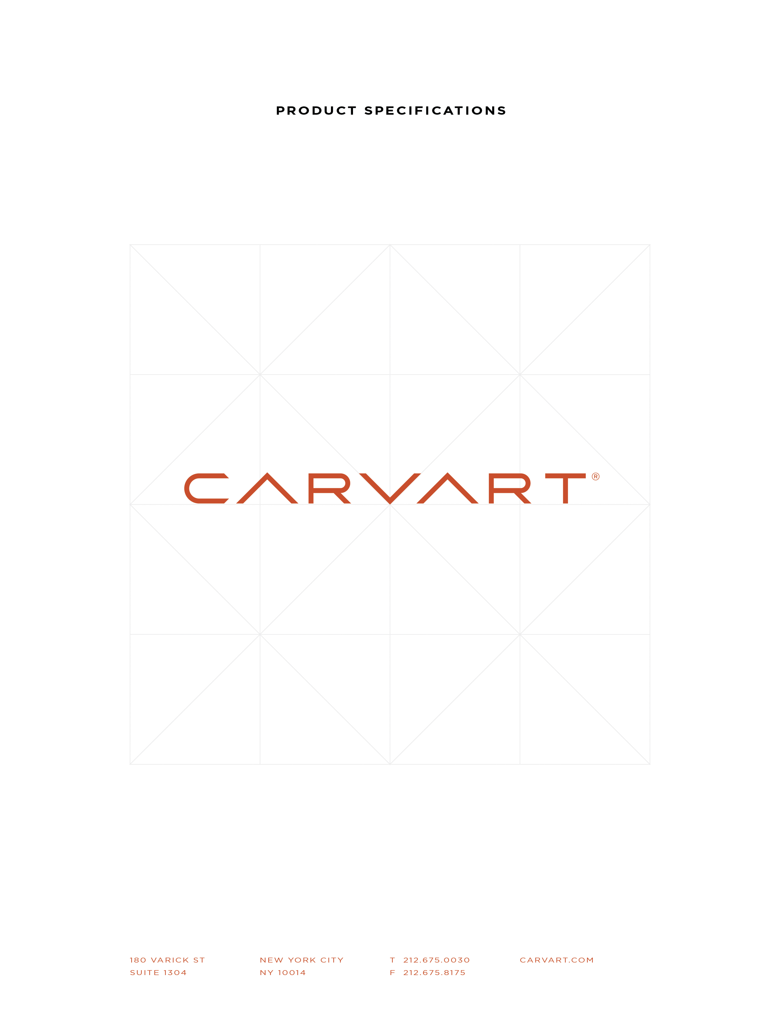

SECTION 10 11 16
Sliding Boards
glassBOARDS>glassSLIDING
PART 1 GENERAL
  - SECTION INCLUDES
- Carvart® glassBOARDS, sliding glass boards with aluminum track.
- System is mounted with mechanical fasteners and integrated mounting frame design.
  - RELATED REQUIREMENTS
- (As Needed) Section 06100 Rough Carpentry: Blocking and requirements for fastening wall and ceiling products.
- (As Needed) Section 092216 Non-Structural Metal Framing: Framing and blocking for metal framing.
  - REFERENCE STANDARDS
- ASTM B221 Standard Specifications for Aluminum and Aluminum-Alloy Extruded Bars, Rods, Wires, Profiles and Tubes.
- ANSI Z97.1 Standard for Glazing Materials Used in Buildings - Safety Performance Specifications and Methods of Test.
- GANA (Glass Association of North America) Glazing Manual.
- GANA (Glass Association of North America) Glass Design Guide.
  - SUBMITTALS FOR INFORMATION
- Material descriptions, sell-sheets, color charts, hardware information, construction and anchoring details,
- Samples: Submit 4” x 4” glass square samples of material and thickness specified for each color and finish indicated.
- Installation guidelines.
  - QUALITY ASSURANCE
- Installer Qualifications: Engage an experienced installer who has been trained to install glass and aluminum wall-hung systems similar in design and extent to those indicated for this product.
- Perform Work in accordance with [GANA Glazing Manual,] [GANA Sealant Manual,] [and] [GANA - Laminators Glass Design Guide] for glazing installation methods.
  - DELIVERY, STORAGE & FIELD CONDITIONS
- Ordering: Comply with manufacturer's ordering instructions and lead time requirements to avoid construction delay.
- Deliver materials to Project site in undamaged condition.
- Store and handle system components and related materials to prevent deterioration or damage due to moisture, temperature changes, contaminants, corrosion, breakage, chipping, or other causes.

  - WARRANTY
- Submit a written limited warranty executed by the manufacturer stating that the glass board systems are free from defects in materials and workmanship and agree to replace glass board systems that do not retain their original qualities within the specified warranty period.
- Warranty covers replacement of defective boards but does not include cost of shipping, removal or reinstallation.
- Warranty Period: 1 years from date of delivery.
PART 2 PRODUCTS
  - MANUFACTURERS
- glassBOARD Manufacturer: Carvart 1441 Broadway, New York, NY 10018; E-mail info@carvart.com; Website www.carvart.com; Phone (212) 675-0030.
- Substitutions: Not permitted.
  - MATERIALS-- GLASS
- Glass: 8mm thick tempered, low iron glass with polished edges.
- Glass finish/type: [Specify Finish and Type______________________]
- Glass Marker Writing surface: available is smooth or etched surface
- Glass Sizes: [Specify Size:___________]
- Steel Backer: Steel backer is available upon request [Specify if product is to have magnetic backer: Yes or No] Magnetic backer is light gauge steel and should be used with rare-earth magnets, available from Carvart upon request;
  - MATERIALS – HARDWARE
- Top Track aluminum alloy; standard finishes available [Specify Finish]
  - top track with snap on fascia
  - Fastening: assembled with machine screws
  - Glass Clamps: Two per sliding panel
  - Rollers/Trollies: two per sliding panel
  - Pulls/Handles: none [optional, specified during shop drawing phase]
  - MATERIALS – MISC.
- Fixed panels: Provide Bottom Supported substrate to mount fixed alum. extrusion
  - Sliding Panel Guide: mounted to millwork/substrate to keep sliding track in line
  - Continuous Channel (for fixed panels)
PART 3 EXECUTION

  - EXAMINATION
- Carvart is not responsible for installation. Receiver responsible for taking delivery must report any missing or damaged material within 48 hours of delivery to validate any claims. Any materials that are damaged or missing that are identified after the 48 hours will be the responsibility of the receiver/client.
  - PREPARATION
- Field conditions are not the responsibility of Carvart. All substrates and anchoring is to be prepared by end user. Carvart recommends structural plywood blocking for all installations.
- All anchoring is to be specified and performed by end-user provided installer.
  - INSTALLATION
- Deliver in accordance with specified size and Carvart written order.
- Follow manufacturer’s installation guidelines; all installers should be industry professionals and skilled at installing wall-mounted, aluminum and glass products.
- Carvart products should be installed on a sound substrate that is adequate to support the weight of the boards. Installer is responsible for all blocking and anchoring.
- Store in a clean dry location that is climate controlled and protect exposed glass edges to avoid damage during construction and installation.
- Install level and plumb.
  - CLEANING
- Follow GANA Section 01-0300
- Remove labels after Work is complete.
- Clean glass and adjacent surfaces.
- To maintain aesthetics, it is important to clean the glass during and after construction. For routine cleaning, use a soft, clean, grit-free cloth and a mild soap, detergent, or window cleaning solution. Rinse immediately with clean water and remove any excess water from the glass surface with a squeegee. Do not allow any metal or hard parts of the cleaning equipment to contact the glass surface. Clean cubicle components in accordance with manufacturer’s instructions and recommendations.
  - PROTECTION OF FINISHED WORK
- Section 01700: Protecting installed work.
- Protect installed glass from damage during construction.
- Protect installed glass from contact with contaminating substances resulting from construction operations.
- Touch-up, repair or replace damaged products before Substantial Completion. Remove and replace glass that is broken, chipped, cracked, abraded, or damaged in other ways during construction period, including natural causes, accidents, and vandalism.

